2. REGULAR FALSI
Q. WRITE A PROGRAM IN PYTHON TO DEMONSTRATE REGULAR FALSI METHOD
AIM: TO WRITE A PROGRAM IN PYTHON TO DEMONSTRATE NEWTON RAPHSON METHOD
PROGRAM:
import math
# Evaluate the user-defined function safely
def safe_eval(expr, x):
try:
return eval(expr.strip(), {"x": x, "math": math, "m": math, "_builtins_": None})
except (NameError, TypeError, ZeroDivisionError, SyntaxError) as e:
print(f"Error evaluating function: {e}")
return None

def Regula_Falsi(Func_str, a, b, tol):
Fa = safe_eval(Func_str, a)
Fb = safe_eval(Func_str, b)

if Fa is None or Fb is None:
return None

if Fa * Fb >= 0:
print("Invalid interval. F(a) and F(b) must have opposite signs.")
return None

print("\nIter.\t a\t\t b\t\t F(a)\t\t F(b)\t\t Xr\t\t F(Xr)")
Xr_old = a # Initial guess to calculate error if needed

for i in range(1, 101):
# Regula Falsi Formula
Xr = (a * Fb - b * Fa) / (Fb - Fa)
FXr = safe_eval(Func_str, Xr)

print(f"{i:<6}\t {a:.4f}\t {b:.4f}\t {Fa:.4f}\t {Fb:.4f}\t {Xr:.4f}\t {FXr:.4f}")

if abs(FXr) < tol:
return Xr

if Fa * FXr < 0:
b = Xr
Fb = FXr
else:
a = Xr
Fa = FXr

print(f"\nRoot not found within 100 iterations (Current error: {abs(FXr):.6f})")
return Xr

print("## Regula Falsi Method ##")
# Example: "x*x - 4*x - 4"
# Example: "m.cos(x) - x"
# Example: "x**3 - x - 1"
# Example: "x*x*x - 4*x - 4"
Func_str = input("Enter the function f(x): ")
a = float(input("Enter the starting value a: "))
b = float(input("Enter the starting value b: "))

tol = float(input("Enter the tolerance value: "))
root = Regula_Falsi(Func_str, a, b, tol)
if root is not None:
print(f"\nApproximate root = {root:.3f} (correct to 3 decimal places)")

OUTPUT:
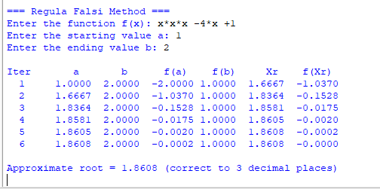

CONCLUSION: The above program has been executed successfully.

